Dominic Drury

06/07/2024

CS-405

5-3 Activity: Static Code Analysis

Visual Studio Error List

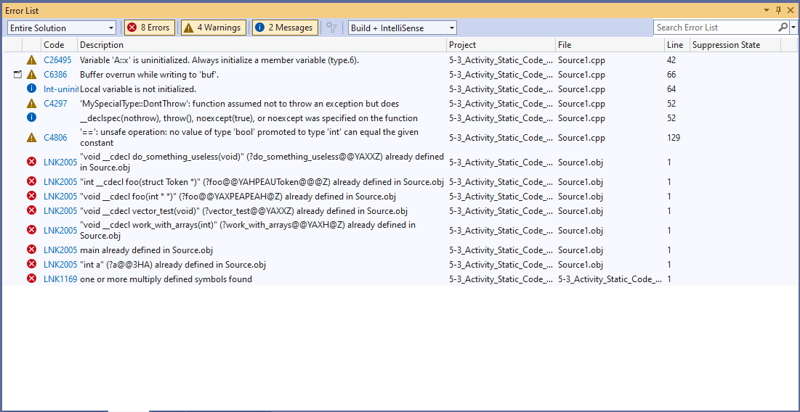

Visual Studio Error List and Execution Results After Repairing Errors From List

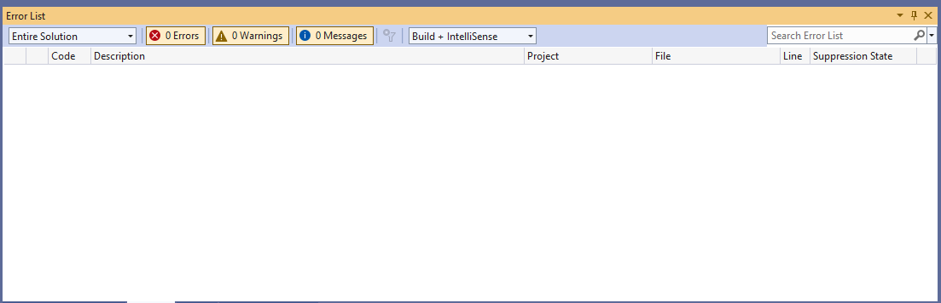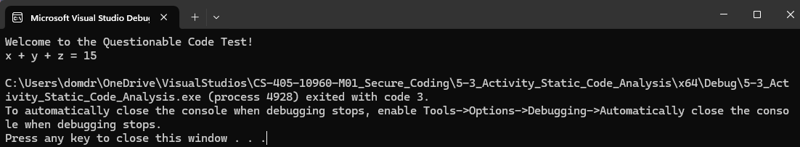

Cppcheck analysis results after clearing visual studio error lists

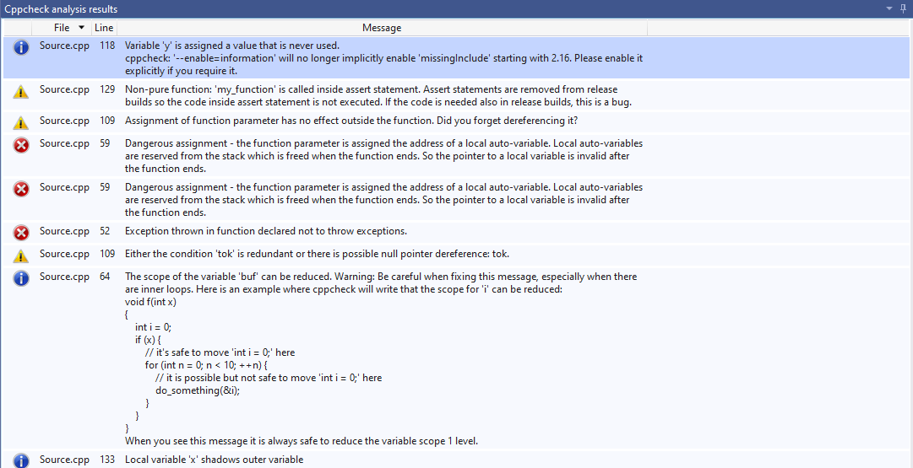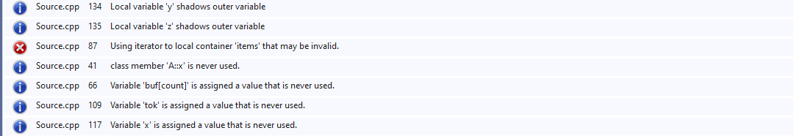

Process Summary

When I first copied the code over there were 2 issues that I had to fix given to me from the Visual Studio Error list. That was that the buf in the work_with_arrays function had an array that was only 10 when it needed to be at least 1001 to accommodate the buf[count] = 0; and the second was that A::x was not initialized so I added {} brackets to the int x in order to get that to initialize to 0. Both solutions came from Microsoft’s learn.microsoft.com.

Once those issues were solved Visual Studio had no issues found, but there were still a lot of issues from the Cppcheck analysis results. There were 3 specific errors that I think are the cause of the program crashing. The first is that the address of a local auto-variable is assigned to a function parameter (the void foo(int** a) function. According to the tool this is a dangerous assignment since the local variable will be invalid once the function ends. The second is that there is a throw in a no exception function (DontThrow function) which will cause a crash. Finally, the third issue is that there is an invalid container in the vactor_test function, according to the tool, using this iterator to the local container ‘items’ may be invalid.

Beyond the errors there are several warnings, none of which should cause the system to crash but could have unintended consequences and a lot of messages that either are related to the warnings and errors or are suggestions in improving the code like reducing

scope size for buf, functions that can be made static, and things that are never used.